ICT378 ASSIGNMENT

LEE JIHU (34061648)

4/15/2021

2021

Table of contents

**1.** **Executive summary** 3

**1.1.** **Brief description of event** 3

**1.2.** **Brief methodology of the investigation** 3

**1.3.** **Brief evidence collection and preservation methods** 3

**2.** **Methodology details** 4

**2.1.** **Investigation** 4

**2.2.** **Evidence collection and preservation** 4

**3.** **Finding (1)** 5

**3.1.** **Discussion** 5

**3.2.** **Supporting evidences** 6

**4.** **Finding (2)** 6

**4.1.** **Discussion** 6

**4.2.** **Supporting evidences** 7

**5.** **Finding (3)** 8

**5.1.** **Discussion** 8

**5.2.** **Supporting evidences** 8

**6.** **Finding (4)** 9

**6.1.** **Discussion** 9

**6.2.** **Supporting evidences** 9

**7.** **Finding (5)** 10

**7.1.** **Discussion** 10

**7.2.** **Supporting evidences** 10

**8.** **Finding (6)** 10

**8.1.** **Discussion** 10

**8.2.** **Supporting evidences** 11

**9.** **Finding (7)** 11

**9.1.** **Discussion** 11

**9.2.** **Supporting evidences** 12

**10.** **Summary and conclusion** 13

**11.** **Appendix** 14

**11.1.** **Description of person of interest** 14

**11.2.** **Association diagrams of persons of interest** 14

**11.3.** **Evidence listing** 15

**11.4.** **Evidence Timeline** 15

**11.5.** **Software and tools used in the investigation** 15

**12.** **References** 16

1. **Executive summary**
   1. **Brief description of event**

The case starts with selling used operating workstations from M57.biz. After purchasing a used computer, Aaron Greene, a buyer, finds traces of an older user on the drive while in use. He realized that the previous user did not erase the entire drive. Aaron Greene continued to look at the drive and found documents and videos about drug use and reported it to the police. Police seized the computer purchased by Aaron Greene and investigated him to find out the source. Police investigators found that the computer was sold to Aaron Greene on December 1st after being used for business by Jo, who was originally an employee of M57.biz.

* 1. **Brief methodology of the investigation**

The foundation of this case is in contact with the private sector. M57.biz is a private company owned by Pat McGoo, primarily based on the Windows operating system and most of its work is done by e-mail, but each employee of M57 uses their own preferred software, such as "Outlook" and "Thundbird'. Pat McGoo has authorized replication of all computer equipment used in the M57.biz office, where the first responder rule applies. Under no circumstances should anyone who does not include qualified computer forensic scientists try to reconstruct or reset information on electronic devices or computer systems. During the investigation, the suspect's computer system should be isolated from all other external environments, and all location information on this computer should be kept in photographs and documents.

* 1. **Brief evidence collection and preservation methods**

In this kind of case, even a small mistake can be a fatal error. To reduce this error, it is desirable for computer forensic scientists to come forward and collect evidence. In addition, all processes through which evidence is collected, including date and time, unique characteristics, manufacturing and models, should be recorded with the name of the computer investigator in case evidence is lost during the investigation. And police should generate journals to record this process of evidence collection. Journal is a very essential means of recording and supporting procedures for managing digital evidence. Evidence recorded in the journal can be delivered to the hands of several forensic scientists as the investigation progresses and can be used as a reference accordingly. In addition, once evidence has been collected, digital evidence preservation is needed to ensure that the original copy is not lost. The MD5 (Message Digest 5) method should be applied to verify that the original image and the copy image are identical before proceeding with the evidence copy. The MD5 method also changes the hash value when a file is converted to hash value, so contrasting this allows the evidence file to be determined whether it is forged or tampered with. The report aims to wrap up the above-mentioned drug case, paying attention to the manipulation of evidence images.

1. **Methodology details**
   1. **Investigation**

The investigation is about a computer that Jo sold to Aaron Greene and aims to determine if Jo is involved in a drug case. The police will conclude through the process of obtaining, verifying, and analyzing evidence.

* 1. **Evidence collection and preservation**

|  |  |  |
| --- | --- | --- |
| Source | File name | Image name |
| Original sold computer | jo-2009-11-19.ad1 | jo-2009-11-19 E01 |
| jo-2009-11-19.ad2 |
| Suspect’s replacement computer seized from M57.biz | jo-2009-12-01.ad1 | jo-2009-12-01 E01 |
| jo-2009-12-01.ad2 |
| jo-2009-12-01.ad3 |

If a suspicious computer at M57.biz is identified, an investigation will begin by issuing a search warrant. The following table shows the image files found by forensic experts on the computer which Aaron Green purchased and the computer which is currently using by Jo.

The computer forensic scientist will first make a copy of the original. In this process, the hash value of the evidence file is recorded. In addition, the investigation shall be conducted only on a copy, so that the evidence does not deteriorate during the forensic investigation, and the original copy shall be preserved. And it will use FTK Imager as a forensic tool to proceed with the investigation. The table below shows the hash values of the evidence files using FTK Imager.

|  |  |  |
| --- | --- | --- |
| File Name | MD5 | SHA1 |
| Jo-2009-11-19.E01 | 7018eae468d8bdb7e7ba0de344430ce0 | 15140f627d6b4e7bea6cb3e1f13bddc958f0937d |
| jo-2009-11-19.ad1 | b9e9a8bddfa5e45b01fa88908174d3f5 | 13de6f0b943009d114f4b78387eb8851f0ee5958 |
| jo-2009-11-19.ad2 | b9e9a8bddfa5e45b01fa88908174d3f5 | 13de6f0b943009d114f4b78387eb8851f0ee5958 |
| Jo-2009-12-01. E01 | 95f4d03531877772cfedb76511300eec | 266b9fa983df9026bad8b9eaa008f24c4770e3a0 |
| jo-2009-12-01.ad1 | a40473e9b769f9c9b60fae6f1d2ed8b1 | cb2140706495d0ae0e8139a8df60f01ce51babb1 |
| jo-2009-12-01.ad2 | a40473e9b769f9c9b60fae6f1d2ed8b1 | cb2140706495d0ae0e8139a8df60f01ce51babb1 |
| jo-2009-12-01.ad3 | a40473e9b769f9c9b60fae6f1d2ed8b1 | cb2140706495d0ae0e8139a8df60f01ce51babb1 |

1. **Finding (1)**
   1. **Discussion**

Evidence to be described was found in the directory 'jo-2009-11.ad1/R/ESEA/RCH'. Crucially, a picture of crystal methamphetamine was found in the ‘EMCDDA _Methamphetamine profile_files’ folder. In addition, drug-related documents were found in the same directory that were believed to have helped the suspect to study drugs. See the table below for information on the relevant documents

|  |  |
| --- | --- |
| Name | Description |
| Criminal_Fact_sheet_Methamphetamine.pdf | Facts and information on methamphetamine |
| Drugs_n_you.pdf | Information about frequently known drugs in Singapore |
| SR82_ICE.pdf | Information about methamphetamine in Australia |
| WA Meth Strategy 2016.pdf | Reports on strategies against meth abuse |
| EMCDDA_Methamphetamine profile.html | Website which contains information about methamphetamine |

* 1. **Supporting evidences**

A photo of crystal methamphetamine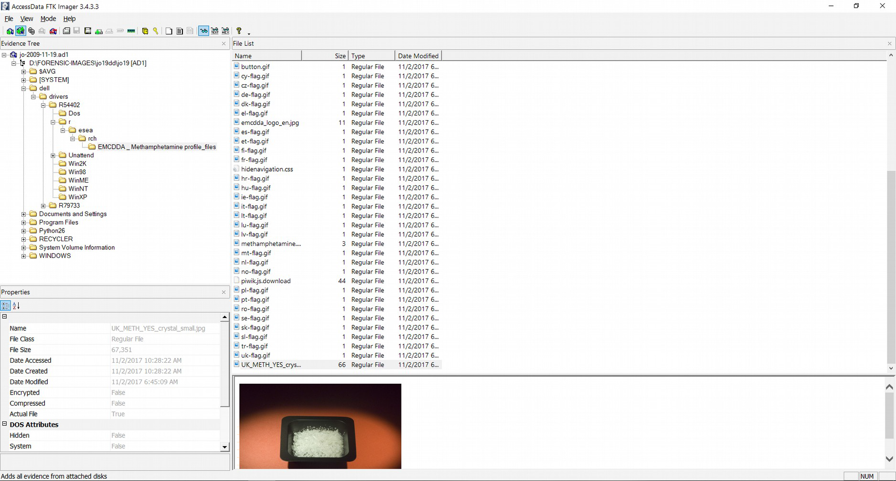List of the related documents found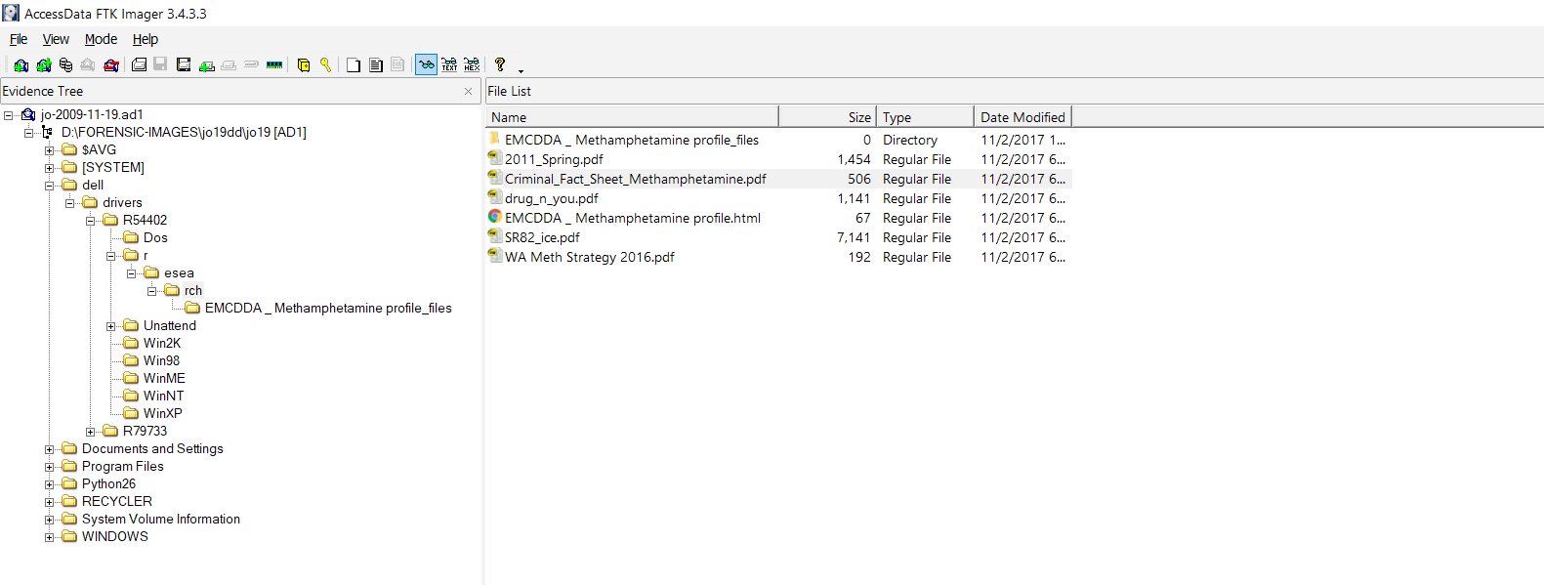

1. **Finding (2)**
   1. **Discussion**

Evidence to be described was found in the directory 'jo-2009-11-19.ad1/documents and settings/my documents/my pictures'. First, 'methamphetamine.gif' was a picture of the bottle, which was tagged with the ingredients of methamphetamine. And ‘1c74e942d9028b455039e27894744cae.jpg’ in the same directory was an image file of the element structure of the methamphetamine. These evidences have information about the structure and ingredients of methamphetamine, which is believed to have helped in the study and manufacture of the components of methamphetamine

* 1. **Supporting evidences**

methamphetamine.gif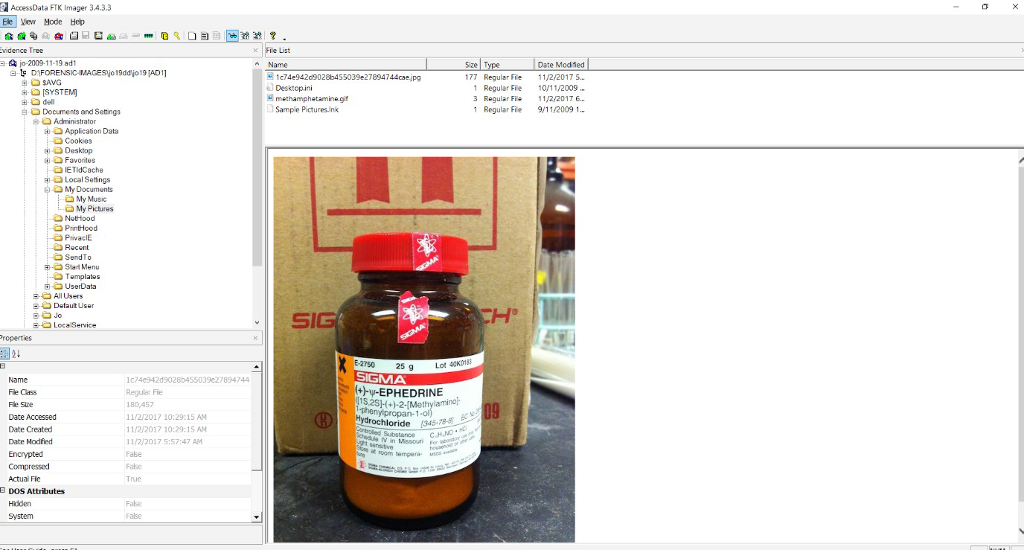1c74e942d9028b455039e27894744cae.jpg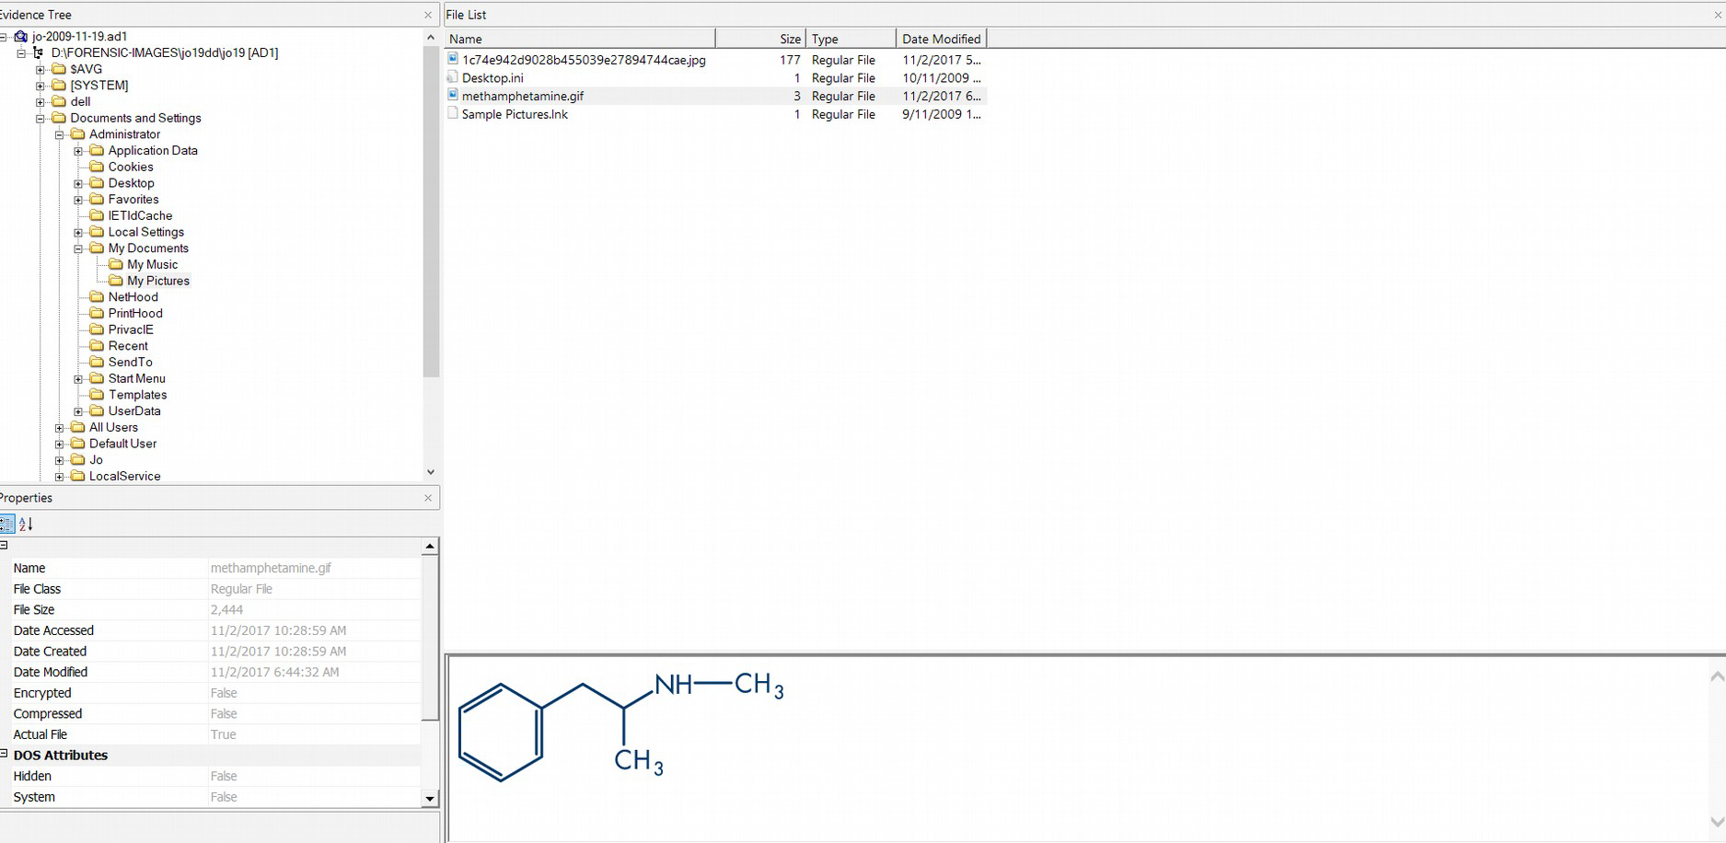

1. **Finding (3)**
   1. **Discussion**

Evidence to be described was found in the directory 'jo-2009-11-19.ad1/documents and settings/jo/mydocuments/downloads'. Several drug-related documents were found in the "Why meth is Becoming an Issue in Singapore_files" folder. The list is as follows.

* cocaine-addiction-long-term-effects-of-cocaine-120x120.jpg
* drug-arrests-singapore-120x120.jpg
* High-Potency-Marijuana-may-Cause-Brain-Damage-1-120x120.jpg
* Meth-Addiction-Singapore-2.jpg
* Singapore-drug-laws-Southeast-Asia-2-120x120.jpg

Links to drug cases and drug law-related articles in Singapore have also been found in the same directory. The user is also believed to have been concerned about the Singapore drug scandal.

* 1. **Supporting evidences**

screen capture of ‘jo-2009-11-19.ad1/documents and settings/jo/mydocuments/downloads/why meth is becoming a problem in singapore_files’ 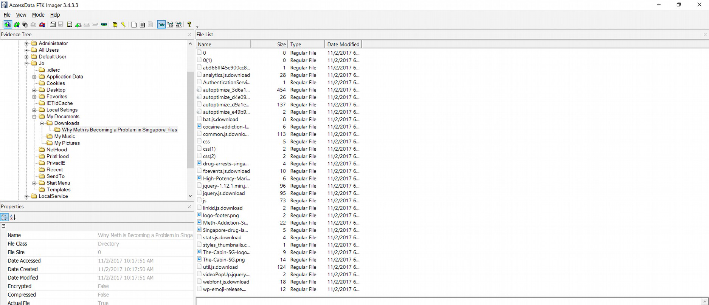

1. **Finding (4)**
   1. **Discussion**

Evidence to be described was found in the directory 'jo-2009-11-19.ad1/documents and settings/all user/shared folder/my voidos'. Four videos were found believed to be associated with Amphetamine and methamphetamine. The list is as follows.

* Amphetamine and Methamphetamine Part 1 – Copy.avi
* Amphetamine and Methamphetamine Part 2 - Copy – Copy.avi
* Amphetamine and Methamphetamine Part 2 – Copy.avi
* Pseudoephedrine Hcl - Uses, Reviews, Side-effects, and Contraindications.avi
  1. **Supporting evidences**

List of the related videos found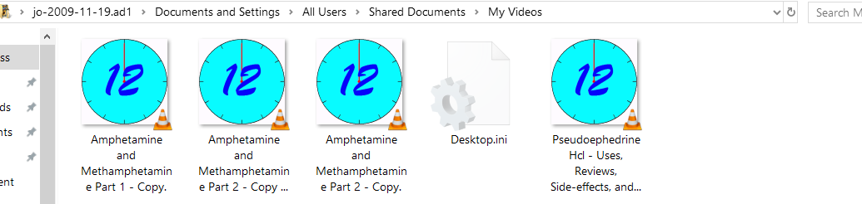

1. **Finding (5)**
   1. **Discussion**

Evidence to be described was found in the directory 'jo-2009-12-01.ad1/documents and settings/administrator/my documents/my pictures'. In this directory, 'shake and bake-copy.jpg' was found, a photograph of a box describing how methamphetamine was manufactured.

* 1. **Supporting evidences**

shakeandbake-copy.jpg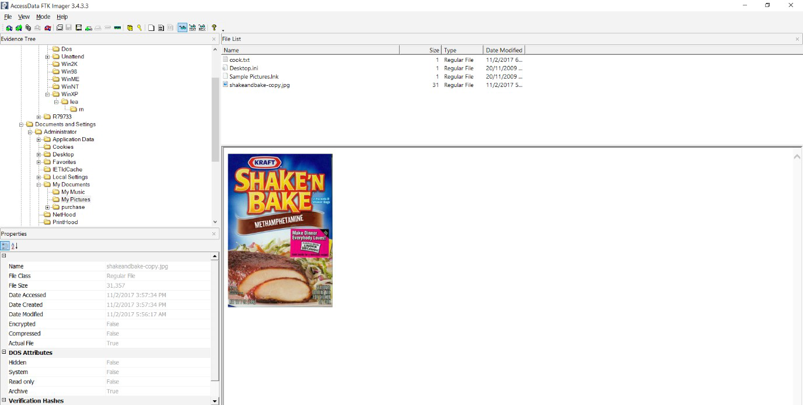

1. **Finding (6)**
   1. **Discussion**

Evidence to be described was found in the directory 'jo-2009-12-01/documents and settings/administrator/my documents/purchases'. Several photos of the detergents were found in the directory, which turned out to be the detergents that contained the ingredients needed to make methamphetamine. There was also an image of 'Vimto_ – Aven Westchem_files' in the same directory, where Vitmo is an online chemical product distributor. It is estimated that the suspect was also thinking about the route of obtaining chemical products.

* 1. **Supporting evidences**

It is one of the images of detergent found in ‘Cleaning Chemicals_Bleach, Car Wash & Drain Cleaner At Bunnings_files’(2c7e4cfb-bd77-4f93-bc30-81843618e957.jpg)and ‘Pool & Spa Chemicals_Pool Stabiliser & Pool Test Kits At Bunnings_files’(54a62a79-b4fe-4786-bcf1-ac9d1309055f.jpg), respectively from the left. Both contain the ingredients needed to make methamphetamine.

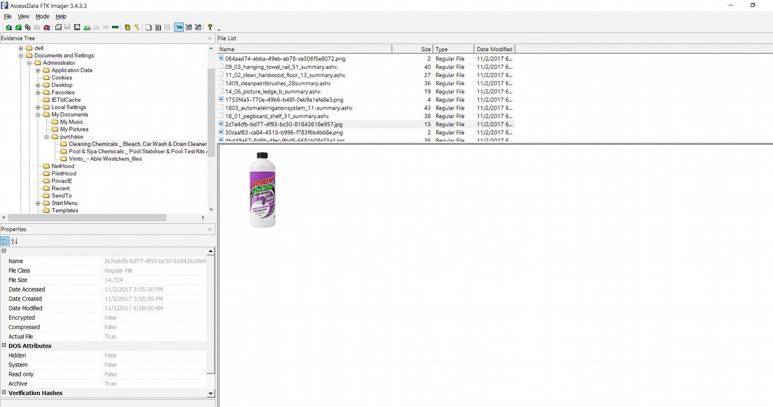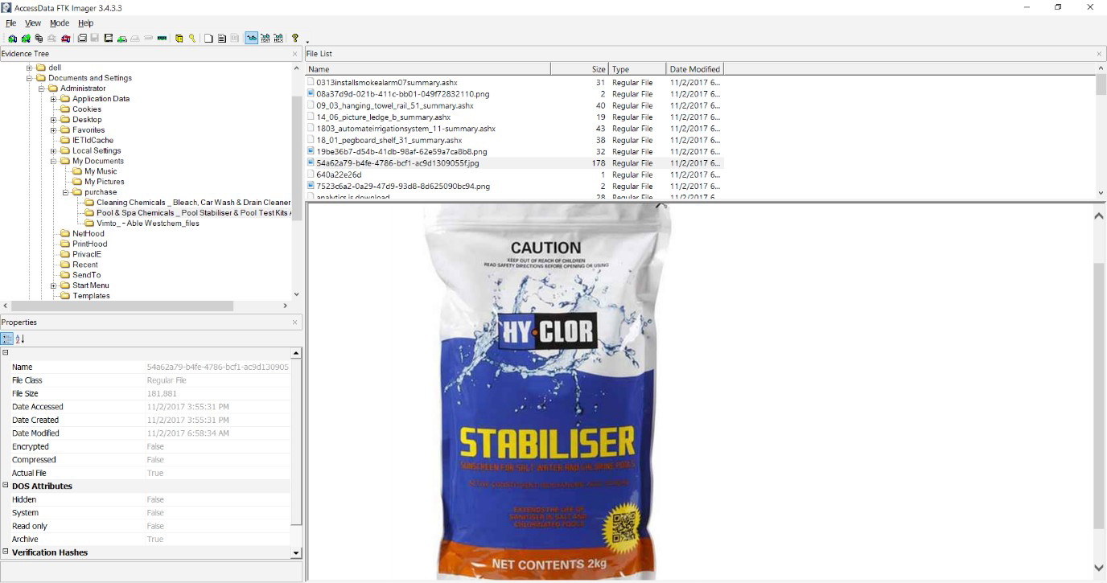

1. **Finding (7)**
   1. **Discussion**

Evidence to be described was found in the directory 'jo-2009-12-01.ad1 in the folder/documents and settings/jo/temporary internet files'. First, in this directory, a folder named 'Where can I find a good methamphetamine recipe_ - Quora_files' and html files are found. This suggests that the user was looking into the manufacture of methamphetamine. Furthermore, many emails were found in the directory 'content.IE5/3F02WNE3', which is a subfolder of the same directory. The content of the mail was a conversation about the use of toolkit to hide images. And traces of testing are found in the directory 'jo-2009-12-01.ad1/documents and settings/jo/desktop/pic'. Judging from this fact, Jo was learning how to hide certain information from the other person, Jordan.

* 1. **Supporting evidences**

Screen capture of the ‘jo-2009-12-01.ad1 in the folder /documents and settings/jo/temporary internet files’ 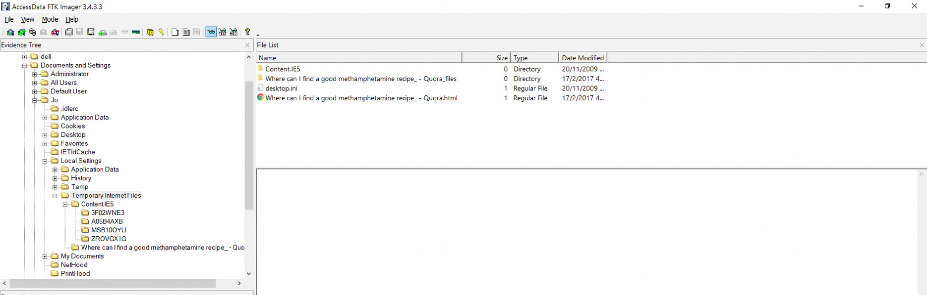

Screen capture of the ‘jo-2009-12-01.ad1 in the folder /documents and settings/jo/temporary internet files/content.IE5/3F02WNE3’ and the part of the contents of the conversation between Jo and Jordan (wbkFA.tmp) 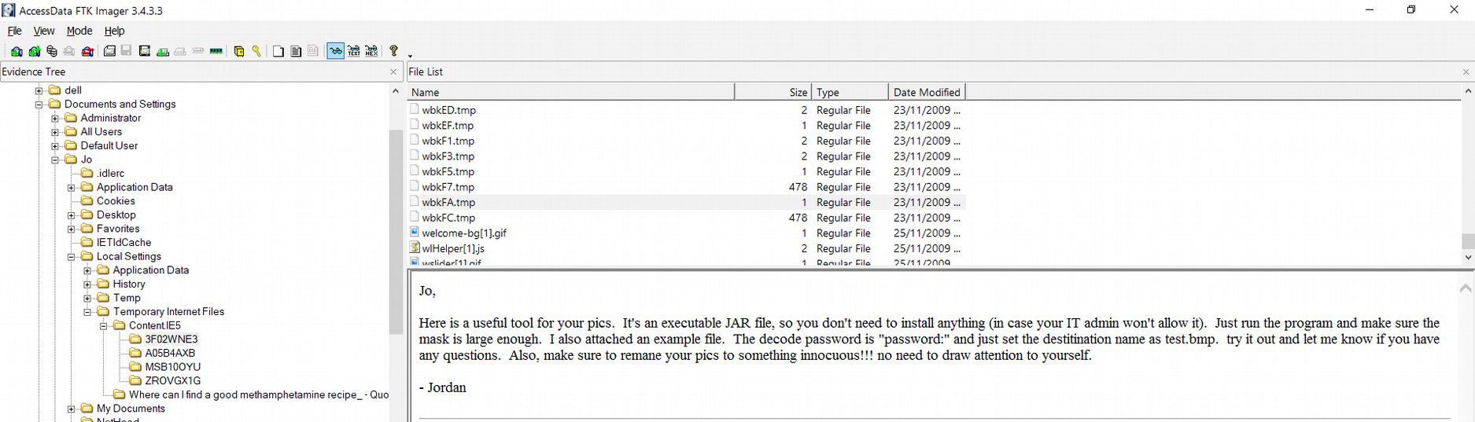Screen capture of the ‘jo-2009-12-01.ad1 in the folder /documents and settings/jo/temporary internet files/content.IE5/3F02WNE3’ and the part of the contents of the conversation between Jo and Jordan (wbk73.tmp) 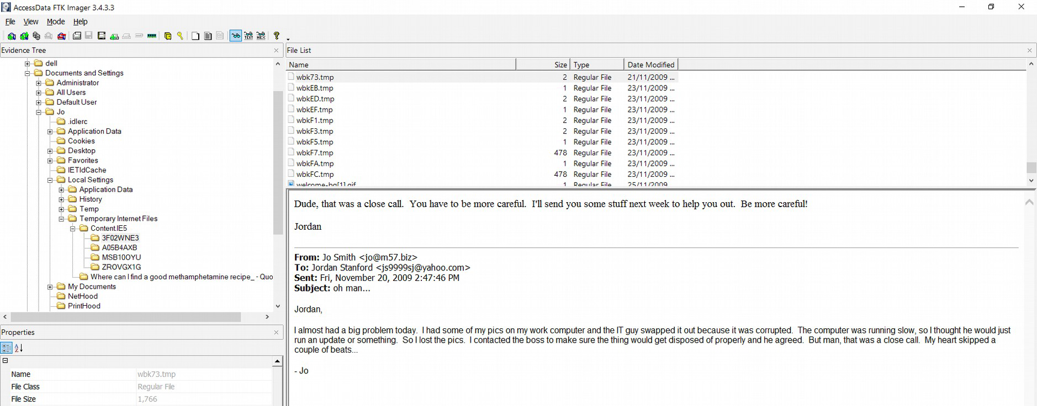

Screen capture of the image hiding toolkit ‘diit-1.5.jar’ and the test files

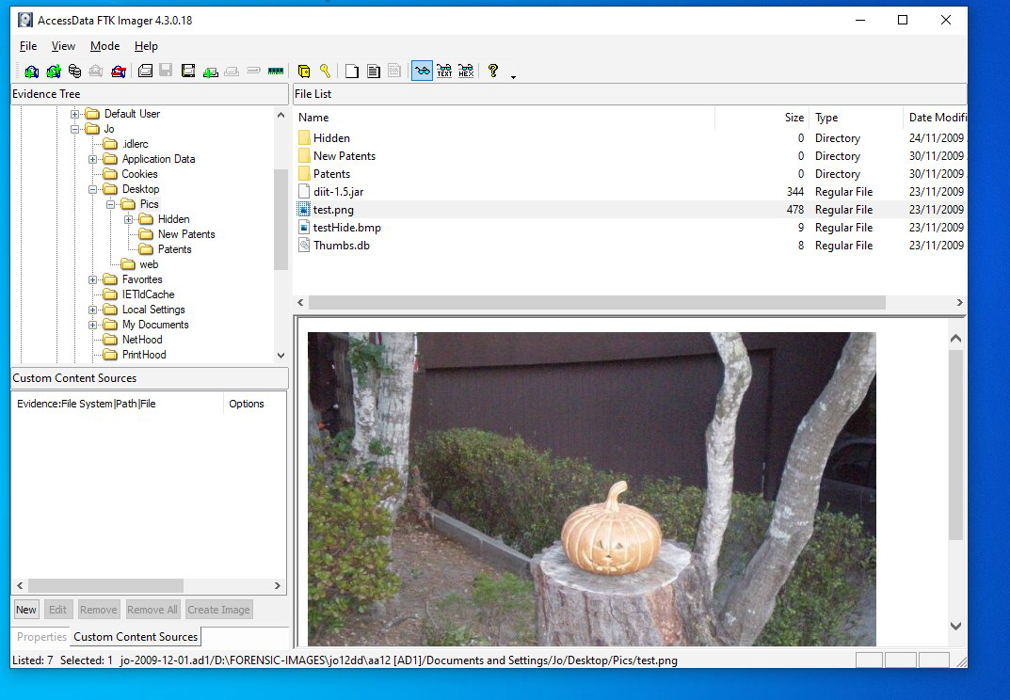

1. **Summary and conclusion**

The result will be concluded by considering each evidence. For the first evidence, the photographs of the methamphetamine crystals and the documents concerning the overall information regarding the methamphetamine. As for the crystal photos, it is not known whether they were manufactured directly by Jo or just had a sample of the photos, but this indicates that Jo is usually very interested in methamphetamine. The second evidence was information of the structure of the components of methamphetamine, indicating that his interest in methamphetamine extends beyond just issues related to methamphetamine itself. For the third evidence, there was a link to articles dealing with social issues about methamphetamine. This is proof that he tried to find out how methamphetamine was treated in society. It gives indirect proof that he is related to methamphetamine. The fourth evidence is drug-related videos. The exact contents are unclear, but judging from the title, this is a drug-related video which is also showing the large interest to drugs. The fifth evidence, an image of a box bearing the method of making methamphetamine, is quite conclusive evidence that he knew how to make methamphetamine. The sixth evidence is an image of the detergents with the ingredients of methamphetamine found on his purchase list. Followed by fifth evidence, it indicates that his production of methamphetamine is already in the working stage. The seventh evidence is simply fatal. He was learning how to hide image files from a man named Jordan who suspected of being an accomplice. Jo and Jordan spoke in a tone of caution not to be caught, and there were files that they had actually test how to hide it. In fact, all parts of the information related to methamphetamine was missing from the E01 type file. This indicates that Jo intentionally concealed the information about methamphetamine.

Judging from the above evidence, it is clear that Jo is involved in illegal drug manufacturing. In particular, manufacturing methods and purchase records are conclusive evidence, respectively, in the fifth and sixth evidence. In addition, the seventh evidence mentions Jordan's alleged accomplice, followed by Boss's presence in 'wdk73tmp'. If Jo's reference Boss is to Boss from his company, it is possible that the entire M57.biz company is involved in illegal drug manufacturing, and Jordan is also a person from the same company. Additional investigations are expected to be made in this regard.

1. **Appendix**
   1. **Description of person of interest**

|  |  |
| --- | --- |
| Name | Description |
| Aaron Greene | The reported person |
| Pat McGoo | CEO of M57.biz, ‘Boss’ suspect |
| Jo | The patent researcher, The prime suspect |
| Charlie | The patent researcher |
| Terry | IT administrator of M57.biz |
| Jordan | ‘accomplice’ suspect, Person who taught Jo how to use the image hiding tool kit. Might be employee of the M57.biz |

* 1. **Association diagrams of persons of interest**

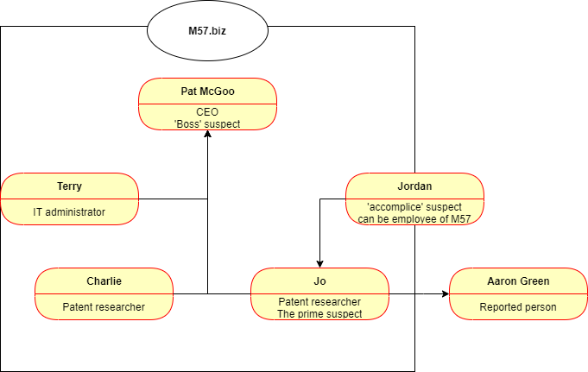

* 1. **Evidence listing**

|  |  |  |
| --- | --- | --- |
| Numbering | Evidence name | Type |
| 1 | UK_METH_YES_crystal_small | jpg |
| 2 | Criminal_Fact_sheet_Methamphetamine | pdf |
| 3 | Drugs_n_you | pdf |
| 4 | SR82_ICE | pdf |
| 5 | WA Meth Strategy 2016 | pdf |
| 6 | EMCDDA_Methamphetamine profile | html |
| 7 | methamphetamine | gif |
| 8 | 1c74e942d9028b455039e27894744cae | jpg |
| 9 | cocaine-addiction-long-term-effects-of-cocaine-120x120 | jpg |
| 10 | drug-arrests-singapore-120x120 | jpg |
| 11 | High-Potency-Marijuana-may-Cause-Brain-Damage-1-120x120 | jpg |
| 12 | Meth-Addiction-Singapore-2 | jpg |
| 12 | Singapore-drug-laws-Southeast-Asia-2-120x120 | jpg |
| 13 | Amphetamine and Methamphetamine Part 1 – Copy | avi |
| 14 | Amphetamine and Methamphetamine Part 2 - Copy – Copy | avi |
| 15 | Amphetamine and Methamphetamine Part 2 – Copy | avi |
| 16 | Pseudoephedrine Hcl - Uses, Reviews, Side-effects, and Contraindications | avi |
| 17 | shake and bake-copy | jpg |
| 18 | 2c7e4cfb-bd77-4f93-bc30-81843618e957 | jpg |
| 19 | 54a62a79-b4fe-4786-bcf1-ac9d1309055f | jpg |
| 20 | Vimto_ – Able Westchem_files | html |
| 21 | wbkFA | tmp |
| 22 | Wbk73 | tmp |
| 23 | diit-1.5 | jar |
| 24 | test | png |
| 25 | testhide | bmp |

* 1. **Evidence Timeline**

The background of the incident seems to be 2009, but important evidences which are modified in 2017 is mixed, so the proper timeline cannot be created.

* 1. **Software and tools used in the investigation**
* FTK Imager
* OS Forensics

1. **References**

Robert C. Newman.(2007). Computer Forensics: Evidence Collection and Management.Auerbach Publication

Kim Etingoff.(2013). Methamphetamine: Unsafe Speed.Simon & Schuster

David Lilburn Watson & Andrew Jones.(2013). Digital Forensics Processing and Procedures: Meeting the Requirements of ISO 17020, ISO17025, ISO27001 and Best Practice Requirements. ELSEVIER

Greg Gogolin.(2013). Digital Forensics Explained.CRC Press

Jason Sachowski.(2019). Implementing Digital Forensic Readiness: From Reactive to Proactive Process.CRC Press

Richard B. Silverman.(2004).The Organic Chemistry of Drug Design and Drug Action.ELSEVIER

Aniket Roy & Rahul Dixit&Ruchira Naskar & Rajat Subhra Chakraborty.(2020). Digital Image Forensics: Theory and Implementation.Springer

Husrev Taha Sencar & Nasir Memon.(2013).Digital Image Forensics: There is More to a Picture than Meets the Eye.Springer